Press Release

Darwin and Telefónica Tech collaborate on cybersecurity of connected autonomous vehicles

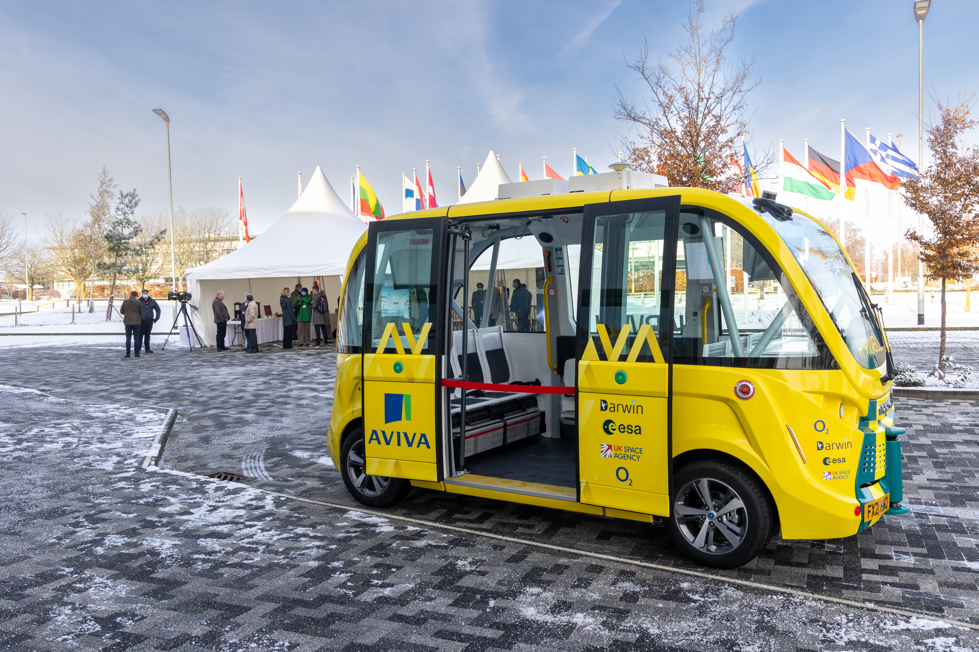

- The two companies are strategically partnering to build a security solution that will span the terrestrial and satellite communication channels of connected autonomous vehicles (CAV).

- Darwin Innovation Group's communications technology enables CAVs to seamlessly switch between satellite and 5G networks, while Telefónica Tech provides the most innovative cybersecurity services to protect these vehicles.

Madrid, 22 December 2021. Communications R&D company Darwin Innovation Group and Telefónica Tech, Telefónica's digital business unit, have signed a strategic agreement to develop a security solution for connected autonomous vehicles (CAV) with technology that combines satellite and terrestrial channels to achieve greater coverage.

The combination of satellite networks and 5G opens up great possibilities for innovation and, in particular, for the use of autonomous vehicles; and it requires its own security solution, so Telefónica Tech's capabilities will be key.

As a result of this agreement, Telefónica Tech's security experts work in coordination with Darwin's development team to perform penetration tests on Darwin's technology using their experience and knowledge in order to solve the identified vulnerabilities.

With Telefónica Tech's help and capabilities, Darwin will be able to ensure that its technology takes cybersecurity into account at the design level and improves identity processes. The resulting cybersecurity shield will span multiple sectors, securing both terrestrial and satellite channels, so that different networks can be used to support each other without compromising security.

Daniela Petrovic, co-founder of Darwin, says: "We are delighted to have Telefónica Tech as our partner in providing security solutions that span satellite and terrestrial communication channels. Providing a security shield for two very different technologies, with different security protocols and integration points, is no small challenge. As with everything we do at Darwin, we embrace new challenges and are confident that with the help of Telefónica Tech we will be able to deliver the ubiquitous and secure communication systems of the future”.

María Jesús Almazor, CEO of Cybersecurity & Cloud at Telefónica Tech, stresses that "all technological advances must always be accompanied by robust cybersecurity measures and, of course, this includes critical assets such as autonomous vehicles. This agreement with Darwin will allow us to put our cybersecurity expertise to work to first secure and then enhance, from a completely innovative point of view, the communications and identity processes of these types of vehicles”.

About Telefónica Tech
Telefónica Tech is the leading company in digital transformation. The company has a wide range of services and integrated technological solutions for Cybersecurity, Cloud, IoT, Big Data, or Blockchain. For more information, please visit: https://telefonicatech.com/

