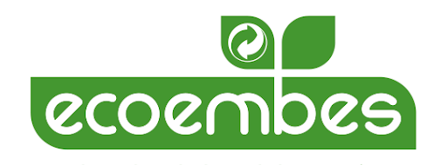
Press Release

Telefónica Tech and Ecoembes collaborate on a pioneering project in the recycling sector

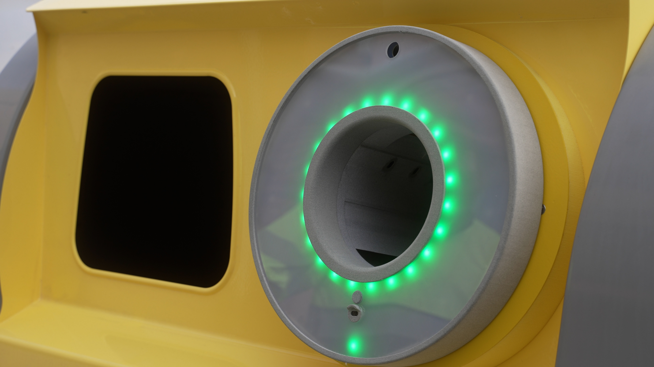

- Telefónica Tech will provide 5G Narrow Band (NB-IoT) connectivity and the integration of this technology through its technology Labs "The Thinx" in the so-called "smart yellow bins".

- Sant Boi de Llobregat (Barcelona) already has 16 connected bins, which are part of Ecoembes' RECICLOS Return and Reward System (SDR), and its citizens can achieve tokenisation benefits for their correct use.

Barcelona, 8th December 2021. Telefónica Tech, the leading company in digital transformation, and Ecoembes, a non-profit environmental organisation that coordinates the recycling of household packaging throughout Spain, have collaborated on a pioneering innovative project in the recycling sector. The project focuses on smart yellow bins, which have a technological ring that recognises the barcode on the packaging and identifies what type of waste is placed inside them.

These rings are connected via 5G Narrow Band connectivity provided by Telefónica Tech, which makes readings possible and transmits them to platforms where the data is managed. The integration has been carried out through the collaboration of "The Thinx", Telefónica Tech's laboratory where companies can test their own production models based on IoT.

Through the data collected by the sensors in the technological rings of the smart yellow containers, it is possible to obtain the traceability of the containers deposited, which allows the collection of relevant data such as what type of waste has been deposited, in what area, at what time or frequency of use. This development aims to reward citizens for recycling beverage cans and plastic bottles and is part of the RECICLOS Return and Reward System (RDS). This RDS, promoted by Ecoembes, rewards citizens for recycling this waste through social and environmental incentives, is present in all autonomous communities and, with the arrival of these new smart yellow bins, takes another step towards the recycling of the future.

The smart yellow bins aim to promote a more efficient and sustainable waste collection, for this, the technological rings that have been installed in them have solar batteries and 5G Narrow Band technology (NB-IoT), which allows to extend the durability of the batteries and a significant improvement in energy consumption in the wireless transmission of information, as well as an increase in the capacity of the system and spectral efficiency.

This pioneering recycling project is being developed in Sant Boi de Llobregat (Barcelona), initially with 16 containers, although Ecoembes has the ambition to take it to more municipalities in Spain.

Citizens' environmental engagement through tokenization

The project includes a part that rewards citizens who can identify themselves, if they have previously logged in to the webapp, and by achieving a series of points (tokens) when recycling, which can then be exchanged for environmental incentives or donated to social causes. If you decide to recycle anonymously, the tokens you earn are not lost, but are added to a generic account that can also be donated to social associations. This entire process is certified through blockchain technology.

According to Elena Gil, Global Director of Products and Business Operations at Telefónica Tech, "with this collaboration with Ecoembes we are enabling an accessible and sustainable technology for public administrations to facilitate recycling and thus support the circular economy".

According to Manuel de Arcocha, Director of Ecoembes Technology at Ecoembes: "With the smart yellow bin we are revolutionising the current reward-based recycling system technologically, taking a leap forward that allows us to face the new challenges and legislative objectives set by Spain and Europe to move towards the much-needed circular economy".

About Telefónica Tech
Telefónica Tech is the leading company in digital transformation. The company has a wide range of services and integrated technological solutions for Cybersecurity, Cloud, IoT, Big Data, or Blockchain. For more information, please visit: https://telefonicatech.com/

About Ecoembes
Ecoembes es la organización ambiental sin ánimo de lucro que coordina el reciclaje de los envases de plástico, las latas y los briks (contenedor amarillo) y los envases de cartón y papel (contenedor azul) en España. En 2020, se entregaron a instalaciones recicladoras 1.490.283 toneladas de envases domésticos procedentes de los contenedores amarillos y azules de la calle, de recogidas selectivas en lugares de gran afluencia y de plantas de residuos municipales. Gracias a ello, se obtuvieron numerosos beneficios ambientales como evitar la emisión de 1,67 millones de toneladas de CO2 a la atmósfera o ahorrar 20,29 millones de m3 de agua y 6,37 millones de Mwh de energía.

