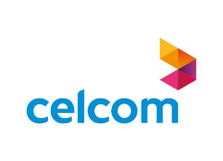
Press Release

Celcom partners Telefónica Tech to enhance Malaysia´s cyber security foray

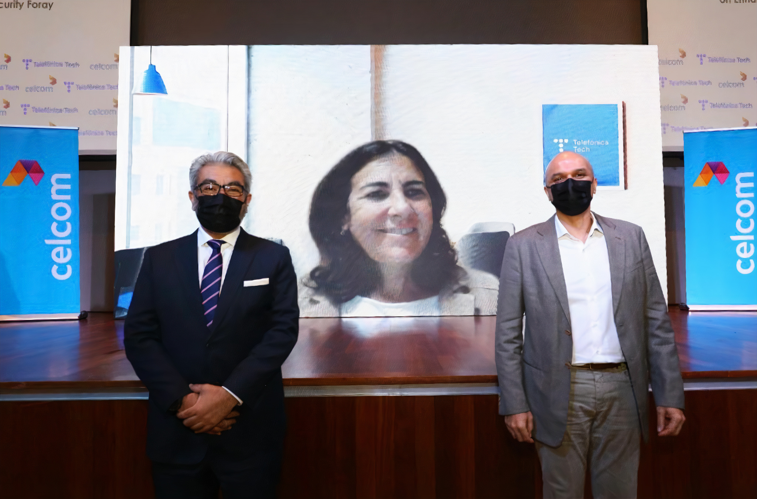
Photo: Mr. Afizulazha Abdullah, Chief Operations Officer (Technology), of Celcom, Dr. Gopi Kurup, Chief Executive Officer of Axiata Enterprise and María Jesús Almazor, CEO of Cloud and Cibersecurity at Telefónica Tech.

- The alliance between the two companies aims to provide best-in-class cybersecurity, privacy and data protection services to Malaysian businesses.

Petaling Jaya, 14 December 2021. Celcom Axiata Berhad (Celcom) continues its drive to become an integrated ICT service provider by sealing a partnership Telefónica Tech, a globally recognised cybersecurity expert. The alliance aims to fortify Celcom’s capabilities in providing full portfolios of cyber security services across multi-vertical industries and organisations in Malaysia.

The partnership with Telefonica Tech, will help strengthen Celcom's position to deliver world-class, resilient and innovative cyber security solutions to Malaysian organisations, safeguarding and ensuring business continuity against potential cyber challenges in the new digital age.

To kick-start the collaboration, Celcom and Telefonica Tech launched two Cyber Threat solutions namely, Digital Risk Protection to identify threats and risk associated with digital assets, and Vulnerability Risk Management which provides analysis for customer assets and the ability to identify potential vulnerabilities in information systems for any organisation.

María Jesús Almazor, CEO of Telefónica Tech Cybersecurity & Cloud, said: "We are very excited about this partnership in Asia-Pacific. Achieved through Telefónica Global Solutions, the partnership is a great step forward in complementing Celcom's ability to develop as an intelligent managed security services provider and benefit from Telefónica Tech's experience and know-how, enabling Celcom to offer new and excellent cybersecurity services needed to protect businesses in this new wave of digitalisation".

Afizulazha Abdullah, Chief Operating Officer (Technology) of Celcom Axiata Berhad said, “Impacts from the pandemic has moved more Malaysian businesses and organisations into the digital ecosystem today, and it is crucial for organisations to be vigilant and safeguard their digital assets. “Celcom’s collaboration with Telefónica Tech will continue to drive digitalisation across local businesses while providing innovative and state-of-the-art cyber security solutions. Combining the expertise of Celcom and Telefónica, local organisations will also receive support for digital risk management which includes consultation for implementation and precautionary security measures that focuses on prevention, detection, and appropriate response to reduce cyber-attacks,” Afiz added.

Under the framework of the partnership agreement signed between Telefónica and Axiata Group back in 2020, both companies have been working together to provide best-in-market technology solutions and digital services to B2B customers from all Axiata Group’s operators. This agreement will bring important benefits to Celcom and Telefónica, and it continues to enhance a strong strategic relationship between both Groups.

Celcom and Telefónica Tech aim to provide more innovative and world-class Cyber Security solutions to complement Celcom’s wide array of digital tools and solutions that aim to assist businesses and organisations to transform their operations swiftly, affordably and securely.

About Telefónica Tech
Telefónica Tech is the leading company in digital transformation. The company has a wide range of services and integrated technological solutions for Cybersecurity, Cloud, IoT, Big Data, or Blockchain. For more information, please visit: https://telefonicatech.com/

About Celcom
Celcom is Malaysia’s first and largest private mobile network operator, with almost 14 million users on its 2G, 3G and 4G LTE+ networks, covering over 98% of the population. Established in 1988, Celcom is now moving towards integrated multi-access, multimedia services and Internet of Things solutions, in line with evolving technologies and consumer behaviour in Malaysia. A culture that places the customer first is reflected in our award-winning customer service, products, and other corporate accolades at a regional level. Celcom is part of Axiata Group Berhad, one of the region’s largest telecommunications groups actively driving digital transformation across a footprint of 9 markets in ASEAN and South Asia. For more information on Celcom, log on to www.celcom.com.my

Media Release Issued by Corporate Communications Department of Celcom Axiata Berhad. For further enquiries, please contact Devindar Visvalingam@ +60192068372 or Azira Mazlan @+60193148002/ azira.mazlan@celcom.com.my

