Press Release

Telefónica Tech joins Ferrovial's initiative to develop the 5G roads of the future

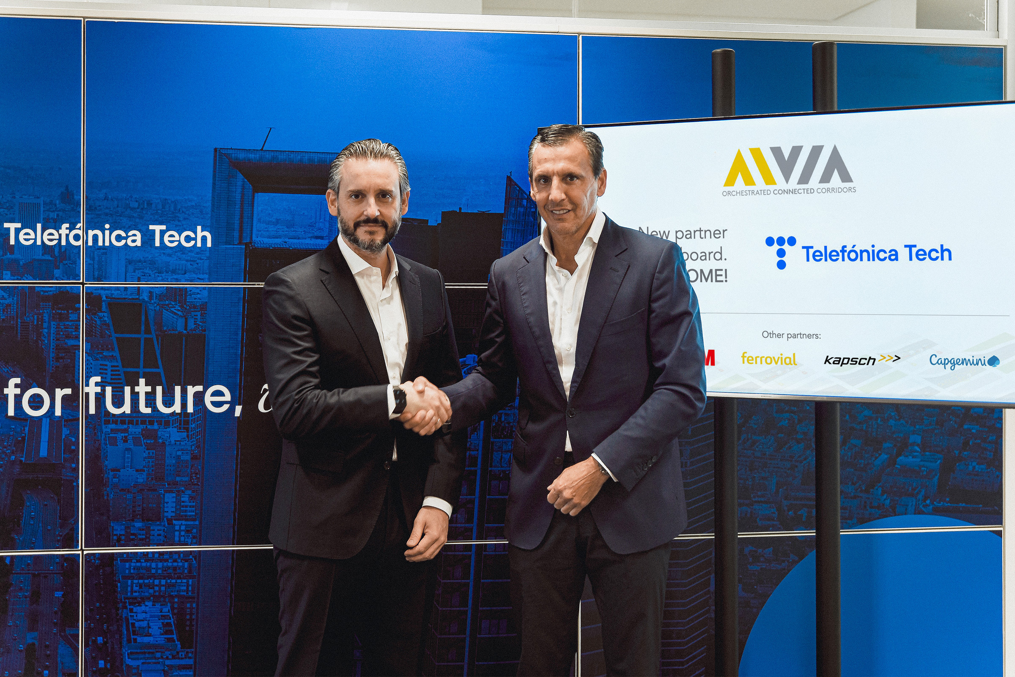
Left to Right: Dimitris Bountolos (Ferrovial) and Jose Cerdán (Telefónica Tech)

- Telefónica's digital business unit is the first Spanish company to take part to the project the project, showing its commitment to the future of mobility.

Madrid, 18 November 2021. Ferrovial has reached an agreement with Telefónica Tech, Telefónica's digital business unit, to join AIVIA Orchestrated Connected Corridors, an initiative to develop 5G smart roads and advanced monitoring, sensing and simulation technology.

5G networks will play a key role in the development of the infrastructures of the future. The use of this technology will allow roads to cease to be a passive actor, providing information to the vehicle that enhances the traveller’s experience and safety, ensures reliable journey times and enables access to infotainment.

In order for a seamless information exchange to take place between the car and the road, both digital and physical infrastructure and orchestrated solutions for the roads of the future need to be implemented. In this way, in addition to greater comfort and safety for users, resources will be optimised and travel times will be saved.

With this agreement, Telefónica Tech joins Microsoft, 3M, Kapsch TrafficCom and Capgemini that are already part of the project. Other companies are expected to be part of the development of these intelligents corridors, which have among their areas of development signalling, road markings, telecommunications equipment, ITS/V2X digital services, road safety systems, etc.

Moving towards future mobility

AIVIA will implement high-speed technologies in mixed traffic that will improve the experience and safety of road users, as well as the operators who maintain them.

"This project stems from Ferrovial's ongoing quest to deliver the infrastructure of the future," said Dimitris Bountolos, Ferrovial's General Manager of Information Systems and Innovation. "Artificial intelligence, edge computing and virtual reality are elements that are already part of the company's day-to-day business. AIVIA perfectly reflects Ferrovial's commitment to innovative and sustainable transport and mobility infrastructure solutions," he concluded.

"The incorporation of Telefónica Tech in this initiative shows our commitment to always be at the forefront of the changing behavioural trends of citizens and companies. This alliance reinforces even more our positioning with connected mobility, being one of the keys to the future, as it allows a large amount of anonymised data to be obtained and processed analysed with advanced technology (Big Data, Edge Computing...) provide very valuable information for business decision making", said Jose Cerdán, CEO of Telefónica Tech.

With a strong international presence, being its main markets Spain, United Kingdom, Germany and Brazil; Telefónica Tech has developed in the last year numerous connected mobility solutions that favour flexibility, efficiency and sustainability. Among others, Telefónica Tech and Ferrovial have implemented the Fleet Optimise technological solution to intelligently manage their vehicle fleets. Thanks to fleet sensorisation, it is possible to reduce journeys and fuel consumption, as well as improve safety and enhance predictive maintenance.

About Telefónica Tech
Telefónica Tech is the leading company in digital transformation. The company has a wide range of services and integrated technological solutions for Cybersecurity, Cloud, IoT, Big Data, or Blockchain. For more information, please visit: https://telefonicatech.com/

About Ferrovial
Ferrovial is one of the leading global infrastructure operators, committed to developing sustainable solutions. The company is listed on the IBEX 35, is part of the Dow Jones Sustainability Index and FTSE4Good, and applies the principles of the United Nations Global Compact, to which the company subscribed in 2002, in all its operations.

