Press Release

Navantia and Telefónica Tech will install a reinforced cybersecurity system in the S-80 class submarines

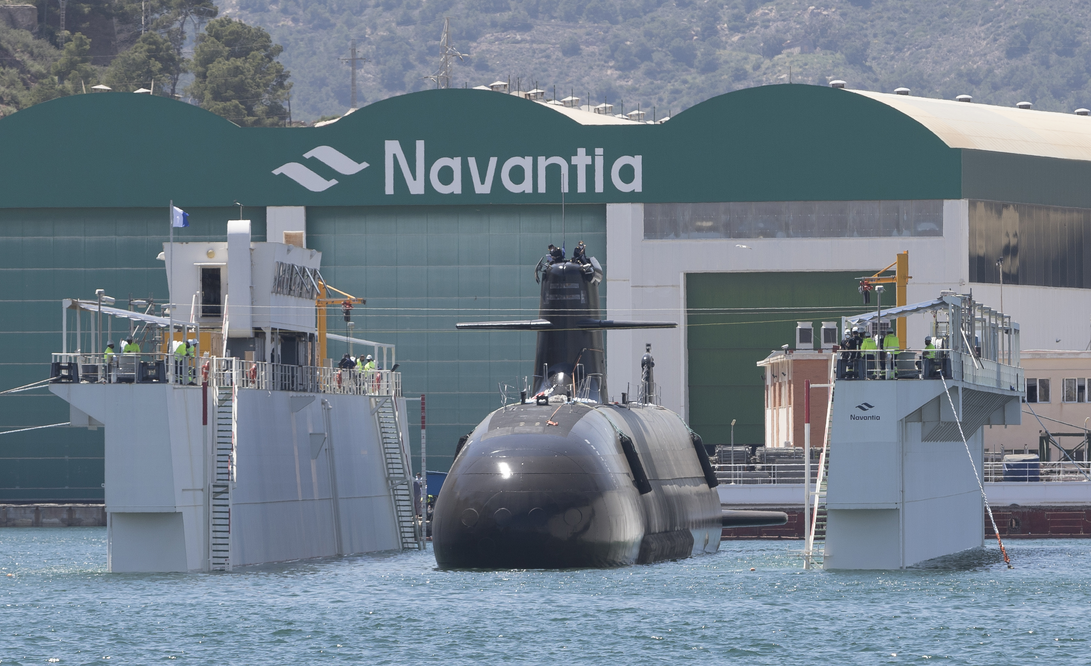

- The system will have strong commonality with the F-110, the Spanish Navy's latest generation frigate.

Madrid, 30 November 2021. Navantia and Telefónica Tech have begun work on the development of a reinforced cybersecurity system for the S-80 class submarines in close collaboration with the Ministry of Defence, which defines the requirements in this area in accordance with the new scenarios posed by digitalisation and the technological challenge.

In a context in which cybersecurity is taking on a growing role in strategic defence, Navantia and the Ministry of Defence have worked on the design of an advanced system that will be incorporated into the submarines in the final phase of construction, as is customary for highly complex products.

The cyberdefence solution is born with the most demanding standards in this area and with a clear directive: to ensure a high degree of commonality with the one that will be incorporated into the F-110 frigates, whose construction will begin soon. Both systems, the one for the S-80 and the one for the F-110, will be developed by Navantia with Telefónica Tech as a partner in its Cybersecurity division.

Navantia, a benchmark in the design and construction of high-tech ships, and Telefónica Tech, a leader in digital transformation and with a wide range of cybersecurity, cloud, Iot, big data and Blockchain solutions, continue to lead advanced solutions in cybersecurity engineering, guaranteeing data sovereignty.

Navantia will supply the cyber defence cabinets for each submarine in the series, will carry out the development of the systems engineering and security engineering and the integration of the main systems of the submarine in the cyber defence. In addition, laboratory test environments or LBTS (Land Based Test Site) will be provided for the development and qualification of the cyber defence system.

The S-80 Cyber Defence will provide the submarine's main systems with protection against cyber-attacks or intrusion attempts. In addition, it will monitor, in real time, the operation of the combat system, the platform's integrated control system and the advanced communications system, alerting in the event of any possible threat detection.

In addition, its advanced logging system will allow forensic analysis, which will enable the study of incidents to identify their origin, the degree of the threat and the mechanism used for the intrusion in order to adopt the appropriate corrective actions.

Last March, Navantia and Telefónica announced an agreement to jointly design, develop and market cybersecurity and integral technological security services, including both the S-80 and the F-110 within the scope of the agreement. The two companies presented their collaboration at the International Defence and Security Fair (FEINDEF) held in Madrid.

About Telefónica Tech
Telefónica Tech is the leading company in digital transformation. The company offers a wide range of services and integrated technological solutions in Cybersecurity, Cloud, IoT, Big Data and Blockchain. For more information go to: https://telefonicatech.com

About Navantia

SMCP is a global leader in the accessible luxury market with four unique Parisian brands: Sandro, Maje, Claudie Pierlot and Fursac. Present in 43 countries, the Group has a network of more than 1,600 shops worldwide and a strong digital presence in all its key markets. Evelyne Chétrite and Judith Milgrom founded Sandro and Maje in Paris in 1984 and 1998 respectively, and continue to exercise the creative direction of the brands. Claudie Pierlot and Fursac were acquired by SMCP in 2009 and 2019, respectively. SMCP is listed on the Euronext Paris regulated market (compartment A, ISIN code FR0013214145, ticker: SMCP).

